**Random Forest**

**Uploading dataset**

**data = read.csv("Dataset_spine.csv")**

**getwd()**

**View(data)**

**summary(data)**

**#Removing Outliers**

**bx=boxplot(data$pelvic_incidence)**

**bx$stats**

**quantile(data$pelvic_incidence,seq(0,1,0.02))**

**data$pelvic_incidence<-ifelse(data$pelvic_incidence>=94,94,data$pelvic_incidence)**

**bx=boxplot(data$pelvic_incidence)**

**bx=boxplot(data$pelvic_tilt)**

**bx$stats**

**quantile(data$pelvic_tilt,seq(0,1,0.02))**

**data$pelvic_tilt<-ifelse(data$pelvic_tilt>=39,39,data$pelvic_tilt)**

**bx=boxplot(data$pelvic_tilt)**

**bx=boxplot(data$lumbar_lordosis_angle)**

**bx$stats**

**quantile(data$lumbar_lordosis_angle,seq(0,1,0.02))**

**data$lumbar_lordosis_angle<-ifelse(data$lumbar_lordosis_angle>=94,94,data$lumbar_lordosis_angle)**

**bx=boxplot(data$lumbar_lordosis_angle)**

**bx=boxplot(data$sacral_slope)**

**bx$stats**

**quantile(data$sacral_slope,seq(0,1,0.02))**

**data$sacral_slope<-ifelse(data$sacral_slope>=70,70,data$sacral_slope)**

**bx=boxplot(data$lumbar_lordosis_angle)**

**bx=boxplot(data$pelvic_radius)**

**bx$stats**

**quantile(data$pelvic_radius,seq(0,1,0.02))**

**data$pelvic_radius<-ifelse(data$pelvic_radius>=146,146,data$pelvic_radius)**

**data$pelvic_radius<-ifelse(data$pelvic_radius<=89,89,data$pelvic_radius)**

**bx=boxplot(data$pelvic_radius)**

**bx=boxplot(data$degree_spondylolisthesis)**

**bx$stats**

**quantile(data$degree_spondylolisthesis,seq(0,1,0.02))**

**data$degree_spondylolisthesis<-ifelse(data$degree_spondylolisthesis>=91,91,data$degree_spondylolisthesis)**

**bx=boxplot(data$degree_spondylolisthesis)**

**#------------------------------------------------------------**

**#Checking correlation between Variables**

**library(car)**

**scatterplot(data$pelvic_tilt,data$Status)**

**mosaicplot(data$Status~data$pelvic_incidence, color='skyblue')**

**library(corrplot)**

**cor(data[,1:8])**

**corrplot(cor(data[,1:8]), method="circle")**

**#Creating Train and Test data.**

**set.seed(1234)**

**splitIndex <- createDataPartition(data$Status, p = .70,list = FALSE, times = 1)**

**trainSplit <- data[ splitIndex,]**

**testSplit <- data[-splitIndex,]**

**print(table(trainSplit$Status))**

**print(table(testSplit$Status))**

**prop.table(table(trainSplit$Status))**

**prop.table(table(testSplit$Status))**

**#Random Forest model**

**library(randomForest)**

**modelrf <- randomForest(as.factor(Status) ~ . , data = trainSplit, do.trace=T)**

**modelrf**

Call:

randomForest(formula = as.factor(Status) ~ ., data = trainSplit, do.trace = T)

Type of random forest: classification

Number of trees: 500

No. of variables tried at each split: 3

OOB estimate of error rate: 16.59%

Confusion matrix:

Abnormal Normal class.error

Abnormal 131 16 0.1088435

Normal 20 50 0.2857143

P N

P Tp fn

N Fp tn

**#Checking variable importance in Random Forest**

**importance(modelrf)**

MeanDecreaseGini

pelvic_incidence 7.302535

pelvic_tilt 8.579979

lumbar_lordosis_angle 7.940512

sacral_slope 7.437386

pelvic_radius 12.991508

degree_spondylolisthesis 23.748114

pelvic_slope 3.446864

Direct_tilt 3.580621

thoracic_slope 4.456488

cervical_tilt 5.164046

sacrum_angle 4.898668

scoliosis_slope 4.682147

**varImpPlot(modelrf)**

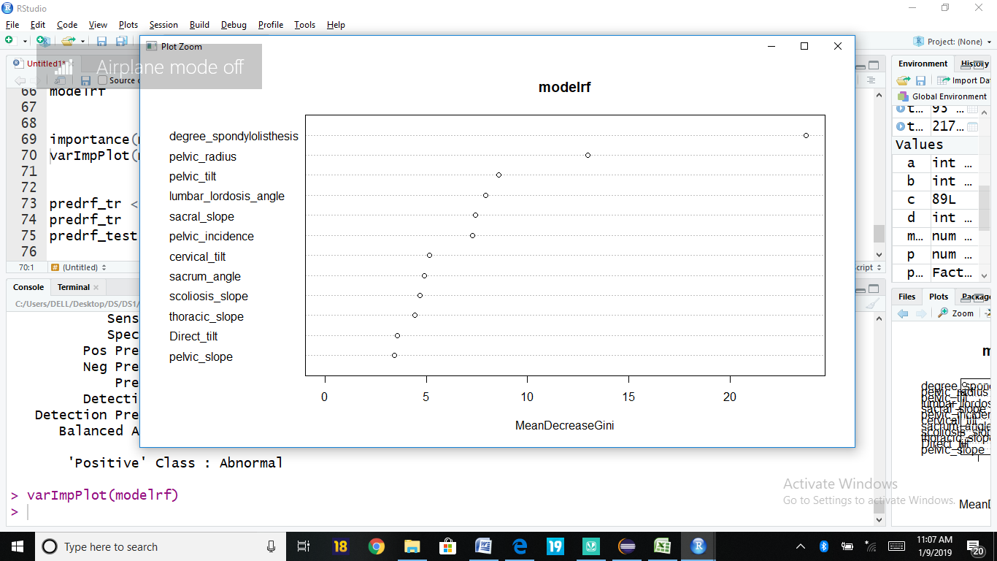

**#Prediction and Model Evaluation using Confusion Matrix**

**predrf_tr <- predict(modelrf, trainSplit)**

**predrf_test <- predict(modelrf, testSplit)**

**confusionMatrix(predrf_tr,trainSplit$Status)**

Confusion Matrix and Statistics

Reference

Prediction Abnormal Normal

Abnormal 147 0

Normal 0 70

Accuracy : 1

95% CI : (0.9831, 1)

No Information Rate : 0.6774

P-Value [Acc > NIR] : < 2.2e-16

Kappa : 1

Mcnemar's Test P-Value : NA

Sensitivity : 1.0000

Specificity : 1.0000

Pos Pred Value : 1.0000

Neg Pred Value : 1.0000

Prevalence : 0.6774

Detection Rate : 0.6774

Detection Prevalence : 0.6774

Balanced Accuracy : 1.0000

'Positive' Class : Abnormal

**confusionMatrix(predrf_test,testSplit$Status)**

Confusion Matrix and Statistics

Reference

Prediction Abnormal Normal

Abnormal 56 7

Normal 7 23

Accuracy : 0.8495

95% CI : (0.7603, 0.9152)

No Information Rate : 0.6774

P-Value [Acc > NIR] : 0.0001313

Kappa : 0.6556

Mcnemar's Test P-Value : 1.0000000

Sensitivity : 0.8889

Specificity : 0.7667

Pos Pred Value : 0.8889

Neg Pred Value : 0.7667

Prevalence : 0.6774

Detection Rate : 0.6022

Detection Prevalence : 0.6774

Balanced Accuracy : 0.8278

'Positive' Class : Abnormal